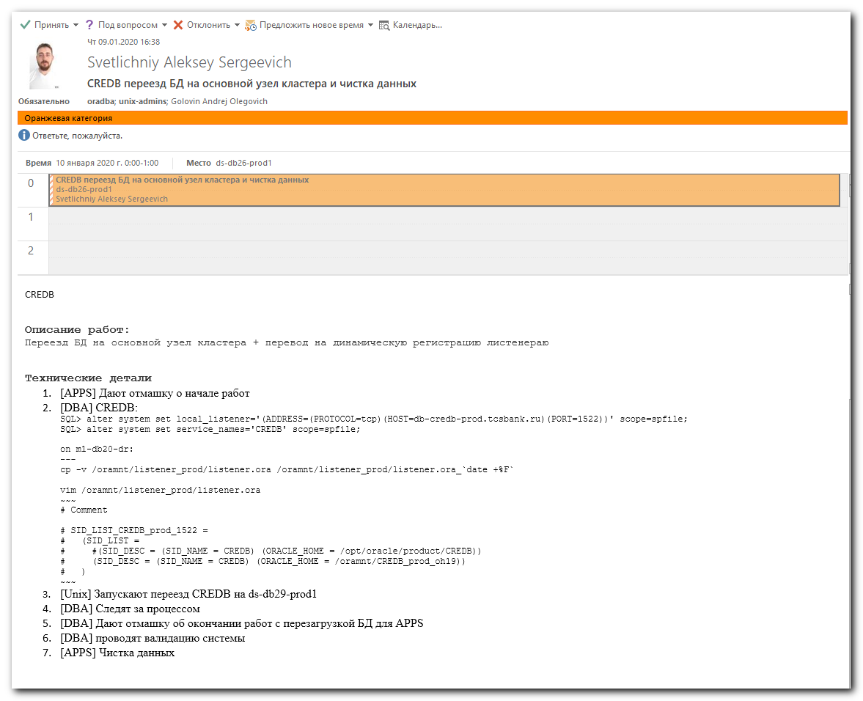

[19:04:28 root@ds-db29-prod2 ~]# hastatus -sum | grep -e "CREDB"
B OraCREDB ds-db29-prod1 Y N OFFLINE
B OraCREDB ds-db29-prod2 Y N ONLINE
B OraCREDB m1-db29-dr Y N OFFLINE
[19:04:43 root@ds-db29-prod2 ~]# mount | grep -e "CREDB" | awk '{print $1"\t"$3}'
a700-credb-prod-nfs:/CREDB_prod_di03 /oramnt/CREDB_prod_di03
a700-credb-prod-nfs:/CREDB_prod_di08 /oramnt/CREDB_prod_di08
a700-credb-prod-nfs:/CREDB_prod_di06 /oramnt/CREDB_prod_di06
a700-credb-prod-nfs:/CREDB_prod_arch /oramnt/CREDB_prod_arch
a700-credb-prod-nfs:/CREDB_prod_redo /oramnt/CREDB_prod_redo
a700-credb-prod-nfs:/CREDB_prod_di01 /oramnt/CREDB_prod_di01
a700-credb-prod-nfs:/CREDB_prod_di04 /oramnt/CREDB_prod_di04
a700-credb-prod-nfs:/CREDB_prod_di02 /oramnt/CREDB_prod_di02
a700-credb-prod-nfs:/CREDB_prod_di07 /oramnt/CREDB_prod_di07
a700-credb-prod-nfs:/CREDB_prod_di05 /oramnt/CREDB_prod_di05
a700-credb-prod-nfs:/CREDB_prod_home/oh19 /oramnt/CREDB_prod_oh19
a700-credb-prod-nfs:/CREDB_prod_di09 /oramnt/CREDB_prod_di09
a700-credb-prod-nfs:/CREDB_prod_home/base /oramnt/CREDB_prod_base
[19:04:57 root@ds-db29-prod2 ~]# tail -f /var/VRTSvcs/log/engine_A.log
2020/01/09 07:37:36 VCS WARNING V-16-1-50086 Mem usage on ds-db29-prod2 is 83%
2020/01/09 09:37:36 VCS WARNING V-16-1-50086 Mem usage on ds-db29-prod2 is 83%
2020/01/09 10:40:49 VCS INFO V-16-1-53504 VCS Engine Alive message!!
2020/01/09 11:37:36 VCS WARNING V-16-1-50086 Mem usage on ds-db29-prod2 is 83%
2020/01/09 13:37:36 VCS WARNING V-16-1-50086 Mem usage on ds-db29-prod2 is 83%
2020/01/09 14:40:50 VCS INFO V-16-1-53504 VCS Engine Alive message!!
2020/01/09 15:37:36 VCS WARNING V-16-1-50086 Mem usage on ds-db29-prod2 is 83%
2020/01/09 17:03:40 VCS INFO V-16-1-50133 User admin has logged in from ::ffff:172.16.28.74
2020/01/09 17:37:36 VCS WARNING V-16-1-50086 Mem usage on ds-db29-prod2 is 83%
2020/01/09 18:40:51 VCS INFO V-16-1-53504 VCS Engine Alive message!!

[19:06:38 root@ds-db29-prod2 ~]#

hagrp -switch CREDB -to ds-db29-prod1

#
# Was nothing special.
# I moved the base, It moved correctly, It took ~3 minutes.
# That’s it.

